Ex. No.: 2

Reg. No. : 210701092

**Word Count Using Map Reduce**

**Input:**

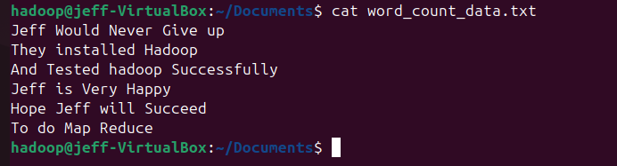

**Output:**

